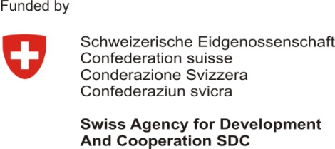 | 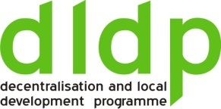 |  | 

Training of LGU staff on Project Cycle Management (PCM)
DAY ONE
Block | Activity | Methodology
1 | - Participants‘ welcome and registration  - Participants‘ and trainers‘ presentation  - Presentation of training workshop objectives, content, and methodology  - Participants‘ expectations | - Interactive presentation of participants in pairs focusing on personal and professional information, especially their experience—as individual and LGU—in project planning and implementation and collaboration with oher LGUs in this area. They present each other to the large group.  - Training workshop objectives and content is emphasized in order to establish mutual understanding and expectations. Inter-LGU cooperation will be emphasized and discussed during the discussion of different seps/components of the project cycle management. The methodology is also described emphasizing that it will be interactive and participatory, based on adult learning theory, and combining different methods (input, small group work, presentation by participants of group work followed by structured groups discussions, case studies/own project ideas, demonstration, etc.).  - Participants‘ expextations are collected and listed under main categories and placed where are visible to participants. It is emphasized that they will be taken into consideration during the training sessions and referred to at the end of the training workshop.
2 | - Project Cycle Management:  - Basic concepts;  - Phases, managment activities, and main decisions/documents.  - Clarifying terms | - Power point presentation on PCM.  Discussion; Questions/Answers
3 | - Steps in project planning (Logical Framework approach) | - Power point presentation on logical framework method
4 | - Situation analysis: Stakeholder analysis | - Power point presentation on stakeholder analysis  Case study/participants‘ project idea: Small group work on stakeholder analysis  Presentation of group work; Questions/Answers
Block | Activity | Methodology
5 | - Situation analysis: Problems analysis  - Conclusions of day 1 | - Power point presentation on problem analysis  Demonstration on pin board with colored papers  Case study/participants‘ project idea: Small group work on problem analysis  Presentation of group work; Questions/Answers  - A general review of day one activities is conducted with participants‘ contribution. Main issues are emphasized and follow up issues identified.
DAY TWO
6 | - Rewiew of day 1  - Objectives analysis | - Quick overview of the discussion of day 1. Re-emphasizing main issues to discuss during day 2.  - Power point presentation on objectives analysis  Demonstration on pin board with colored papers  Case study/participants‘ project idea: Small group work on objectives analysis  Presentation of group work; Questions/Answers
7 | - Alternatives analysis | - Power point presentation on alternatives analysis  Demonstration on pin board with colored papers  Case study: Small group work on alternatives analysis  Presentation of group work; Questions/Answers
8 | - Logical Framework Matrix as a main instrument in PCM  - Hierarchy of objectives (results, goal, products, andactivities) | - Power point presentation on logframe and hierarchy of objectives  Demonstration on pin board with colored papers  Case study/participants‘ project idea: Small group work on hierarchy of objectives  Presentation of group work; Questions/Answers
9 | - Logical Framework Matrix as a main instrument in PCM  - Assumptions  - Conclusions of day 2 | - Power point presentation on assumptions  Demonstration on pin board with colored papers  Case study/participants‘ project idea: Small group work on assumptions  Presentation of group work; Questions/Answers  - A general review of day one activities is conducted with participants‘ contribution. Main issues are emphasized and follow up issues identified.
DAY THREE
10 | - Review of day 2  - Logical Framework Matrix as a main instrument in PCM  - Indicators  - Means of verification | - Quick overview of the discussion of day 1. Re-emphasizing main issues to discuss during day 3.  - Power point presentation on indicators and means of verification  Demonstration on pin board with colored papers  Exercise: Identifying indicators  Case study/participants‘ project idea: Small group work on indicators and means of verification  Presentation of group work; Questions/Answers

Block | Activity | Methodology
11 | - Project proposal document  - Logical Framework Matrix + project organization + budget | - Power point presentation on structure of project proposal document  Case study/participants‘ project idea: Small group work on project proposal organization  Presentation of group work; Questions/Answers
12 | - Project proposal document  - Activity Plan | - Power point presentation on Activity Plan  Case study/participants‘ project idea: Small group work on Activity Plan  Presentation of group work; Questions/Answers
13 | - Conclusions of training workshop  - Next steps | - Small group work on expereince gained and lessons learned  Structured discussion on small group experience and lessons learned  - Different methods are used to identify follow up activities relating to capacity building of LGU staff in project cycle management such as individual input (post-its), structured group discussion, and evaluation forms.

